Lab 4: Advanced Prompt Engineering – Zero-shot, One-shot, and Few-shot Techniques

Lab Objectives:

- To explore and apply different levels of prompt examples in AI-assisted code generation.
- To understand how zero-shot, one-shot, and few-shot prompting affect AI output quality.
- To evaluate the impact of context richness and example quantity on AI performance.
- To build awareness of prompt strategy effectiveness for different problem types.
Lab Outcomes (LOs):
After completing this lab, students will be able to:

- Use zero-shot prompting to instruct AI with minimal context.
- Use one-shot prompting with a single example to guide AI code generation.
- Apply few-shot prompting using multiple examples to improve AI responses.
- Compare AI outputs across the three prompting strategies.

Task #1 – Zero-Shot Prompting with Conditional Validation
Objective
Use zero-shot prompting to instruct an AI tool to generate a function that validates an Indian mobile number.
Requirements
- The function must ensure the mobile number:
  - Starts with 6, 7, 8, or 9
  - Contains exactly 10 digits
Expected Output
- A valid Python function that performs all required validations without using any input-output examples in the prompt.

CODE SNIPPET
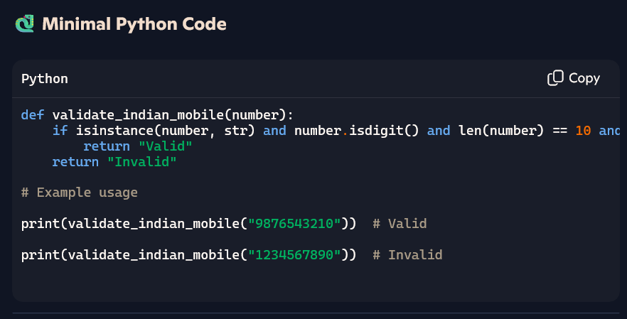
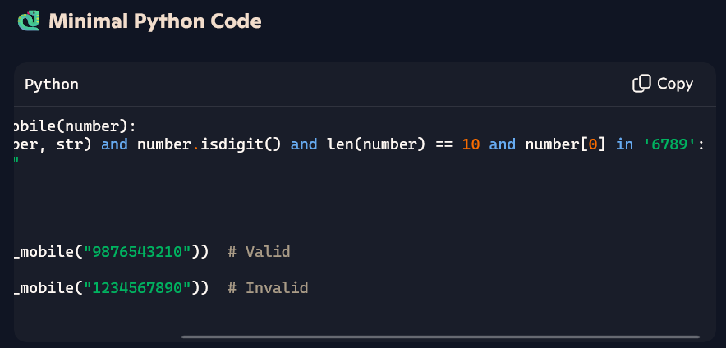

OBSERVATION
- By giving the prompt to generate the function for validating the indian mobile number using copilot AI
- I observed that as the indian mobile numbers will start from 6 7 8 9 series I took automatically and used that in code to validate that if numbers starts from 6 7 8 9 series It is valid indian number

Task #2 – One-Shot Prompting with Edge Case Handling
Objective
Use one-shot prompting to generate a Python function that calculates the factorial of a number.
Requirements
- Provide one sample input-output pair in the prompt to guide the AI.
- The function should handle:
  - 0! correctly
  - Negative input by returning an appropriate message
Expected Output
- A Python function with correct factorial logic and edge case handling, generated from a single example.
CODE SNIPPET
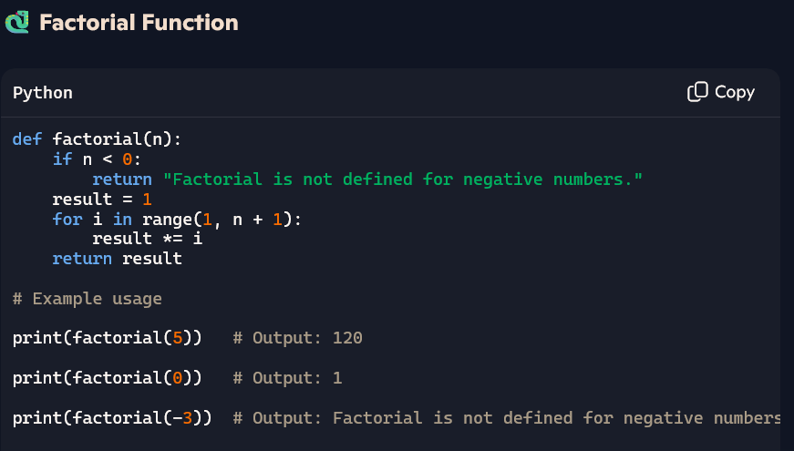

Examples

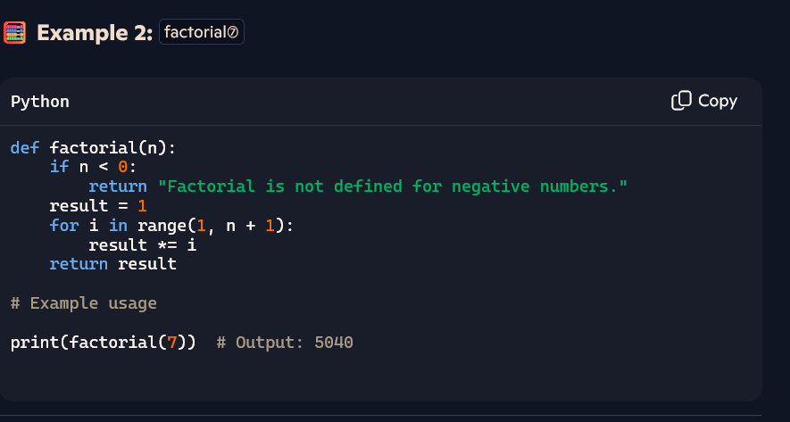
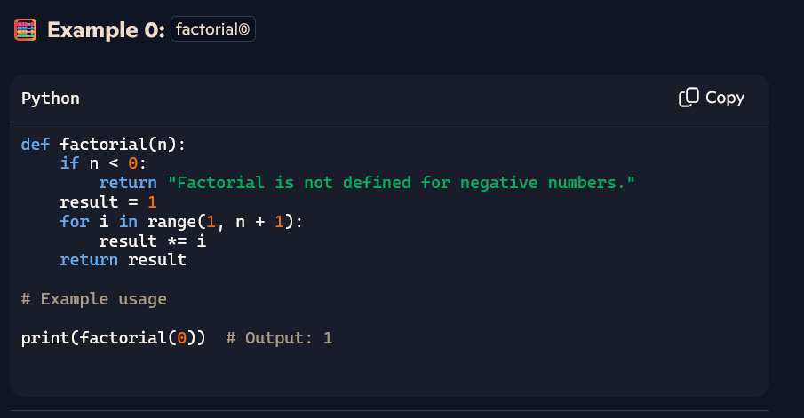
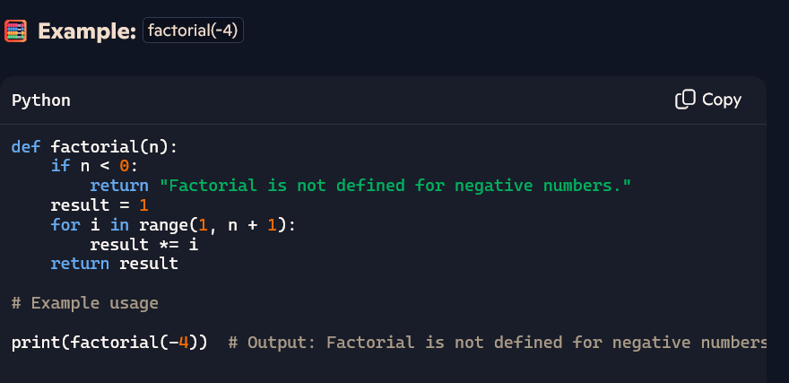
OBSERVATION

- I have observed that copilot AI is giving correct factorial and also giving the appropriate message if we given negative numbers like -4 as factorial not defined for negative numbers

Task #3 – Few-Shot Prompting for Nested Dictionary Extraction
Objective
Use few-shot prompting (2–3 examples) to instruct the AI to create a function that parses a nested dictionary representing student information.
Requirements
- The function should extract and return:
  - Full Name
  - Branch
  - SGPA
Expected Output
- A reusable Python function that correctly navigates and extracts values from nested dictionaries based on the provided examples.

CODE SNIPPET

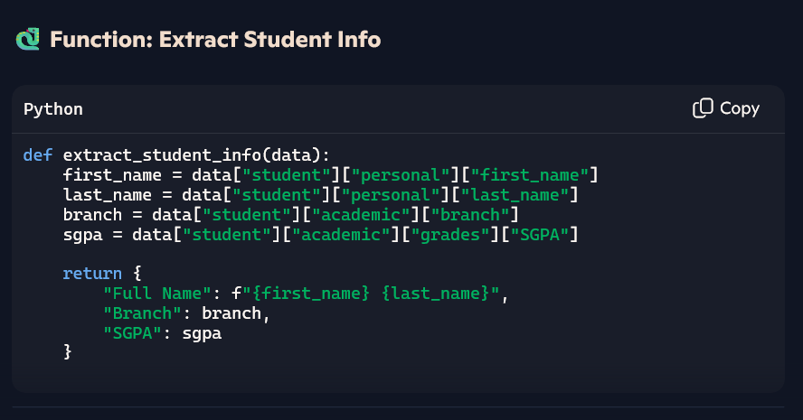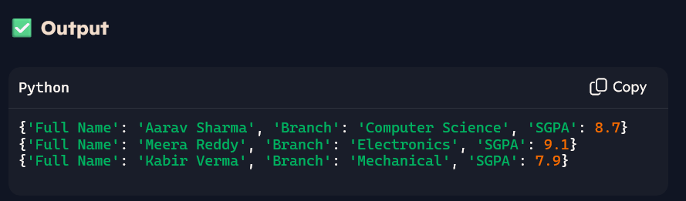

OBSERVATION
The function cleanly extracts Full Name, Branch, and SGPA from a nested student dictionary. It assumes a fixed structure and uses direct key access without error handling. String concatenation builds the full name, and the logic is reusable for similar inputs. To improve robustness, it could include checks for missing fields or support batch processing.

Task #4 – Comparing Prompting Styles for File Analysis
Objective
Experiment with zero-shot, one-shot, and few-shot prompting to generate functions for CSV file analysis.
Requirements
- Each generated function should:
  - Read a .csv file
  - Return the total number of rows
  - Count the number of empty rows
  - Count the number of words across the file
Expected Output
Working Python functions for each prompting style, with a brief reflection comparing their accuracy, clarity, and efficiency

CODE SNIPPET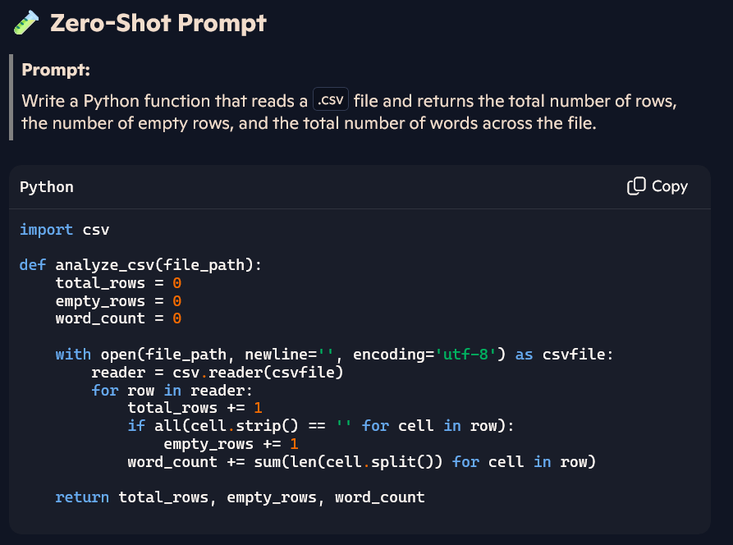

OBSERVATION
- Reasonable output with correct logic.
- Assumes UTF-8 encoding and uses csv.reader appropriately.
- No error handling or edge case consideration.

CODE SNIPPET
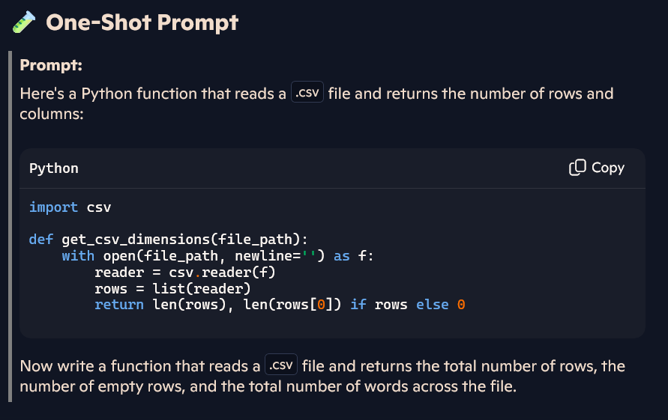
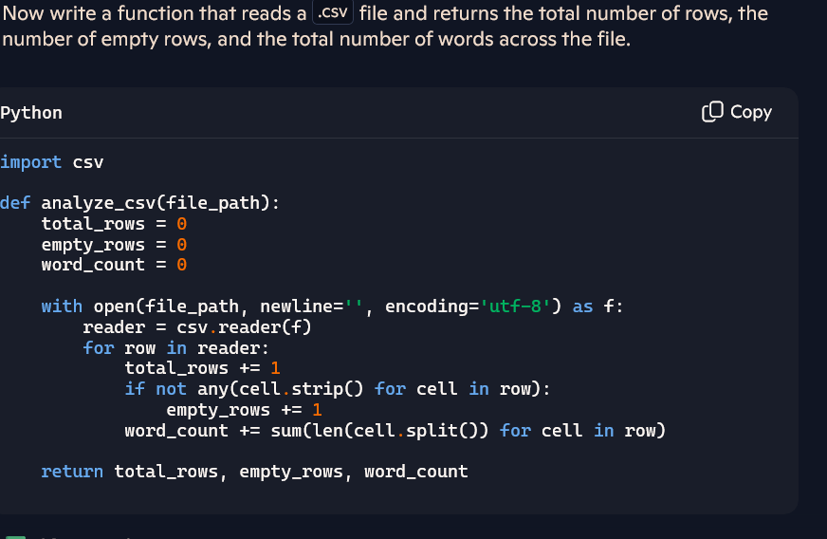
OBSERVATION
- Slightly refined logic for empty row detection (not any(...)).
- Mimics style and structure of the example.
- Still no exception handling or file existence checks.

CODE SNIPPET
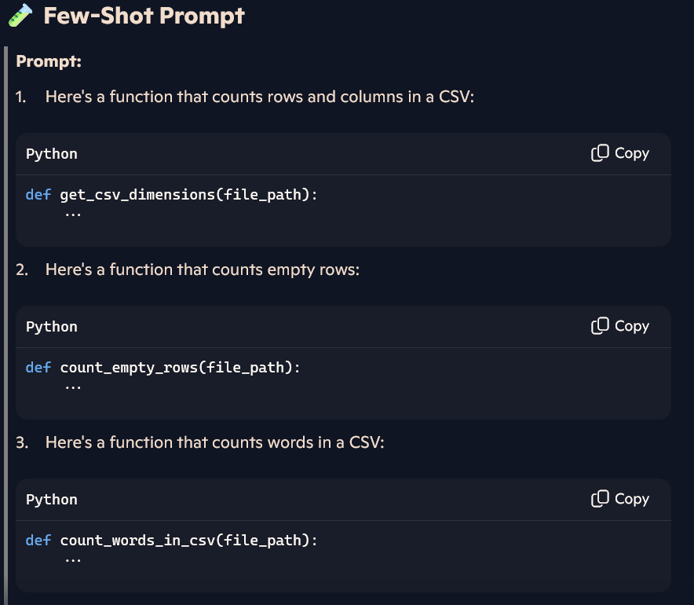
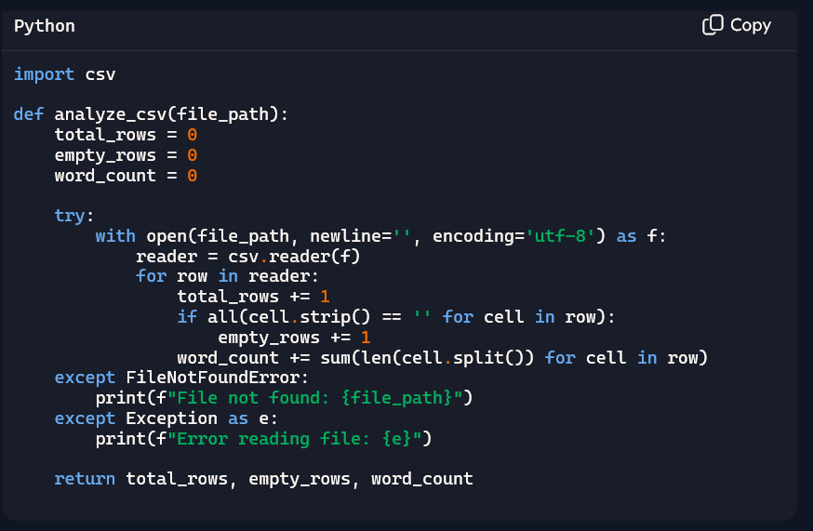
OBSERVATION
- Incorporates exception handling.
- More robust and complete.
- Reflects synthesis of multiple examples.
Summary
- Zero-shot is great for quick prototyping—concise and functional, but brittle.
- One-shot improves logic clarity by learning from a single example.
- Few-shot delivers the most robust and production-ready code, balancing clarity with fault tolerance.

Task #5 – Few-Shot Prompting for Text Processing and Word Frequency
Objective
Use few-shot prompting (with at least 3 examples) to generate a Python function that processes text and analyzes word frequency.
Requirements
The function must:
- Accept a paragraph as input
- Convert all text to lowercase
- Remove punctuation
- Return the most frequently used word
Expected Output
A functional Python script that performs text cleaning, tokenization, and returns the most common word using only the examples provided in the prompt

CODE SNIPPET
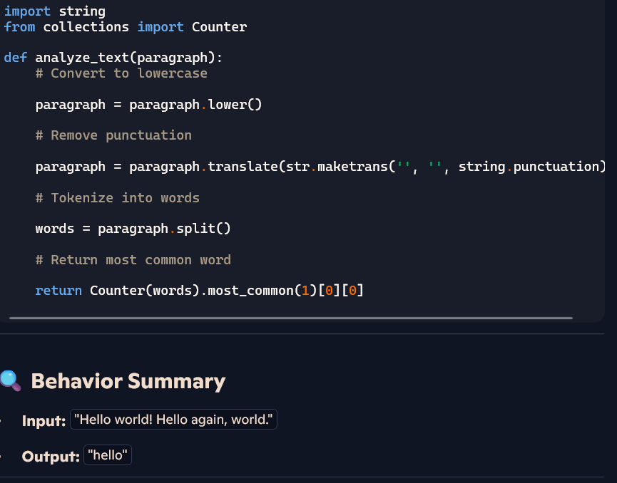
OBSERVATION
  - The script faithfully synthesizes the examples into a complete solution. It’s accurate, minimal, and adheres strictly to the constraints of few-shot prompting. The only minor gap is lack of edge-case handling, which wasn’t covered in the examples—so its omission is consistent with the prompt.

